**Харківський національний економічний університет**

**імені Семена Кузнеця**

**ЗВІТ**

**З ВИКОНАННЯ Індивідуального завдання**

**за дисципліною: *“Інформаційні системи та інтернет технології***”

**Виконав: студент факультету Інформаційних технологій**

**3 курсу, спец. Кібербезпека,**

**групи 6.04.125.010.21.2**

**Бойко Вадим Віталійович**

**Перевірила:**

**Солодовник Ганна Валеріївна**

**ХНЕУ ім. С. Кузнеця**

**2023**

**Завдання:**

1. Вибір здобувачем трьох елементів з будь-якого сайту з нетривіальними стилями та поведінкою (зміна стилю, розташування, відображення контенту за підведення курсора або за натискання на цей елемент; введеня даних за допомогою форми, подальша їх обробка та надання результатів обробки тощо);
2. опис тегів HTML, правил CSS та коду JavaScript, за допомогою яких були створені обрані елементи сайта;
3. − написання висновків до роботи.

Елементів має бути не менше трьох. Звіт має містити посилання на обраний сайт та екрані форми обраних елементів

Сайт: <https://www.google.com/>   
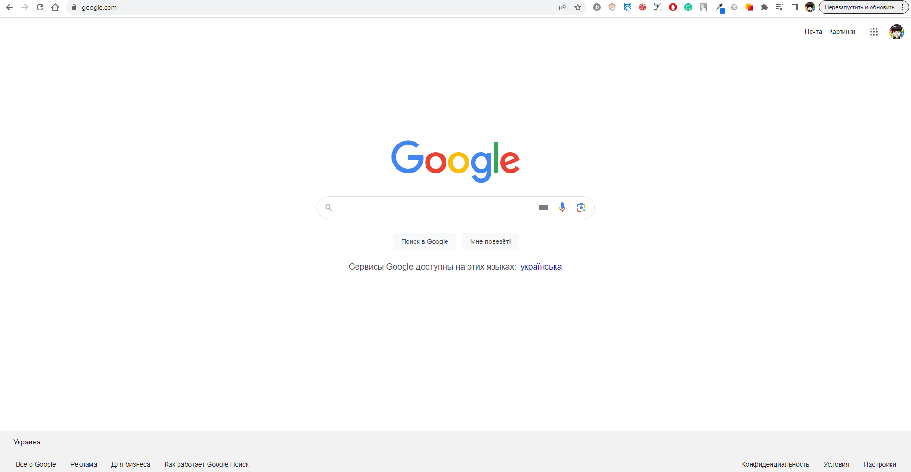

Зміна стилів при наведенні курсору:

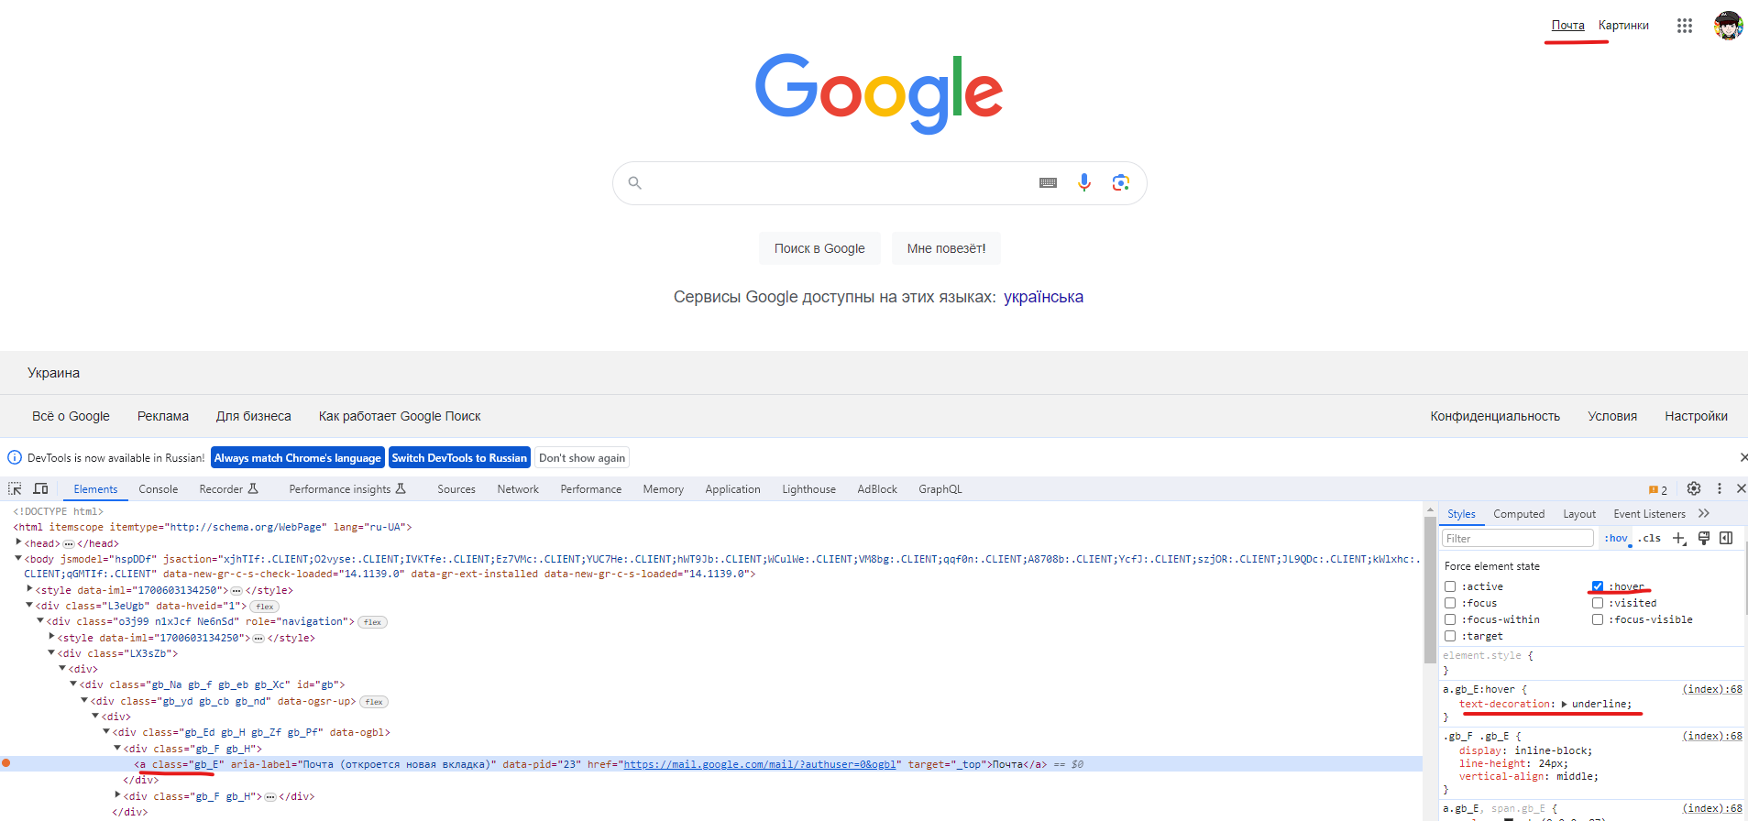

CSS:

*a.gb_E:hover {*

*text-decoration: underline;*

*}*

Анімація при відкритті блоку:

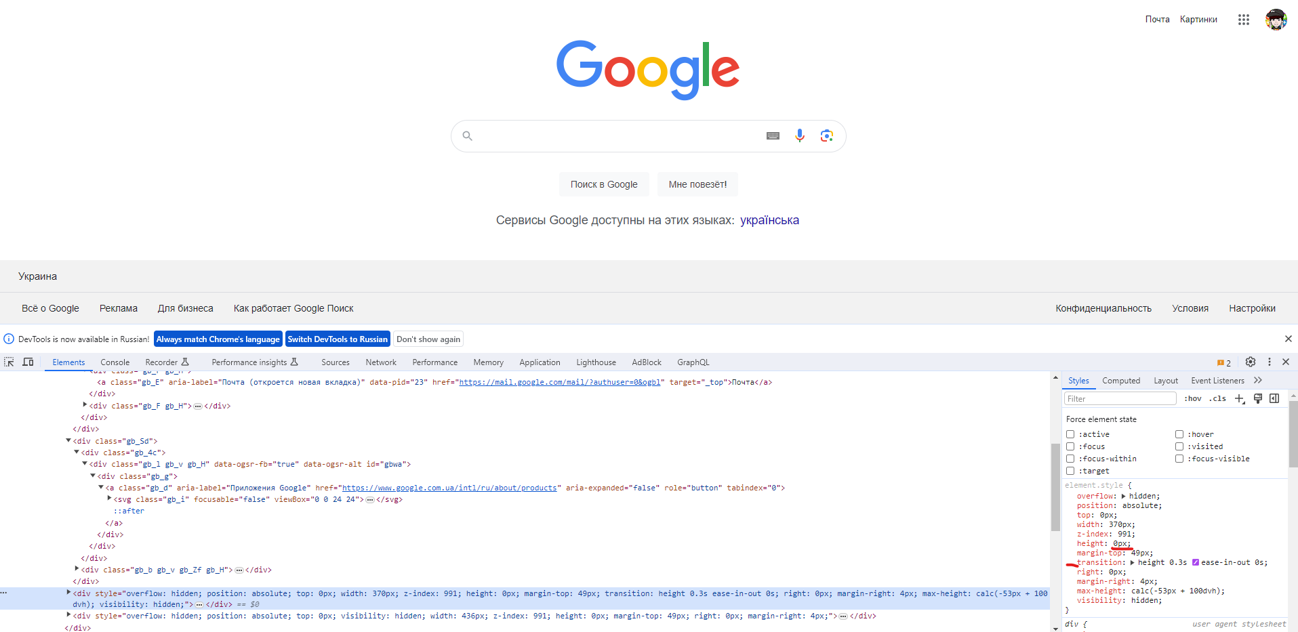

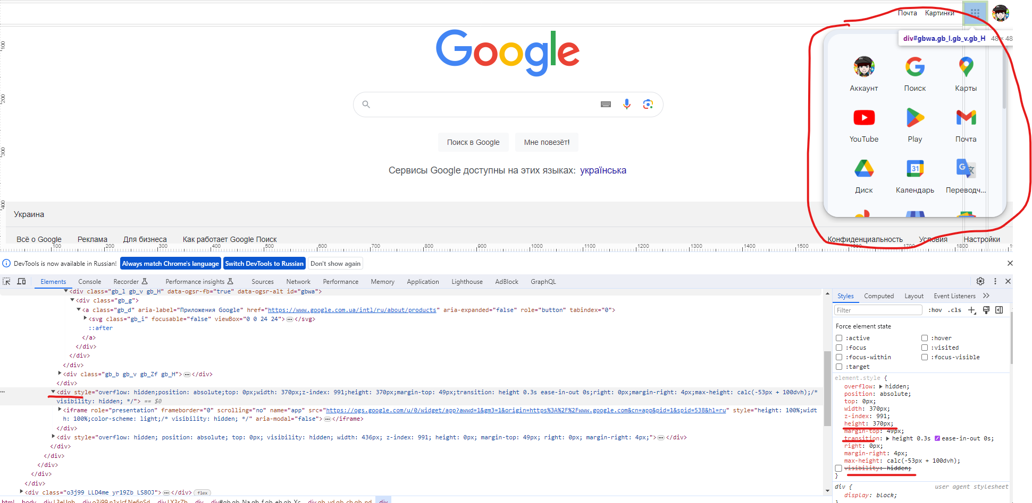

CSS:

*element.style {*

*overflow: hidden;*

*position: absolute;*

*top: 0px;*

*width: 370px;*

*z-index: 991;*

*height: 470px;*

*margin-top: 49px;*

*transition: height 0.3s ease-in-out 0s;*

*right: 0px;*

*margin-right: 4px;*

*max-height: calc(-53px + 100dvh);*

*visibility: visible;*

*}*

Форма:

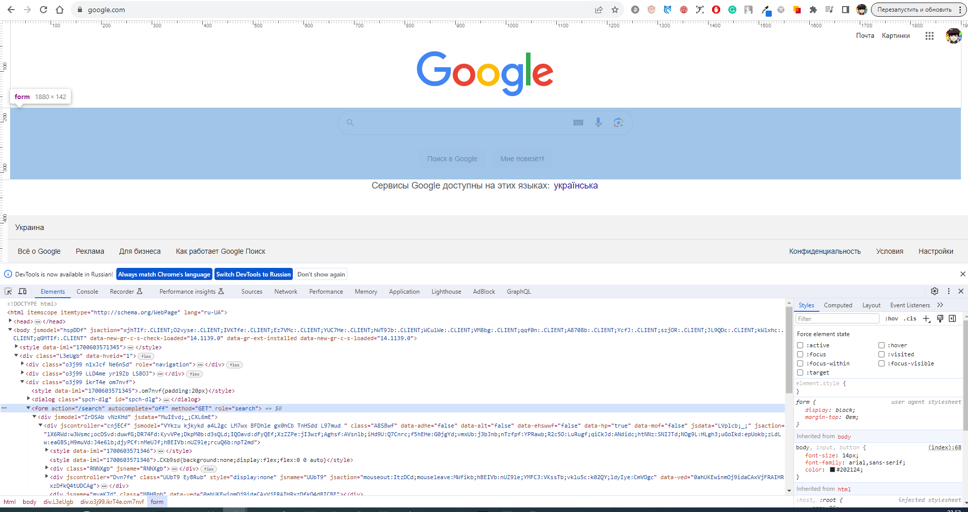

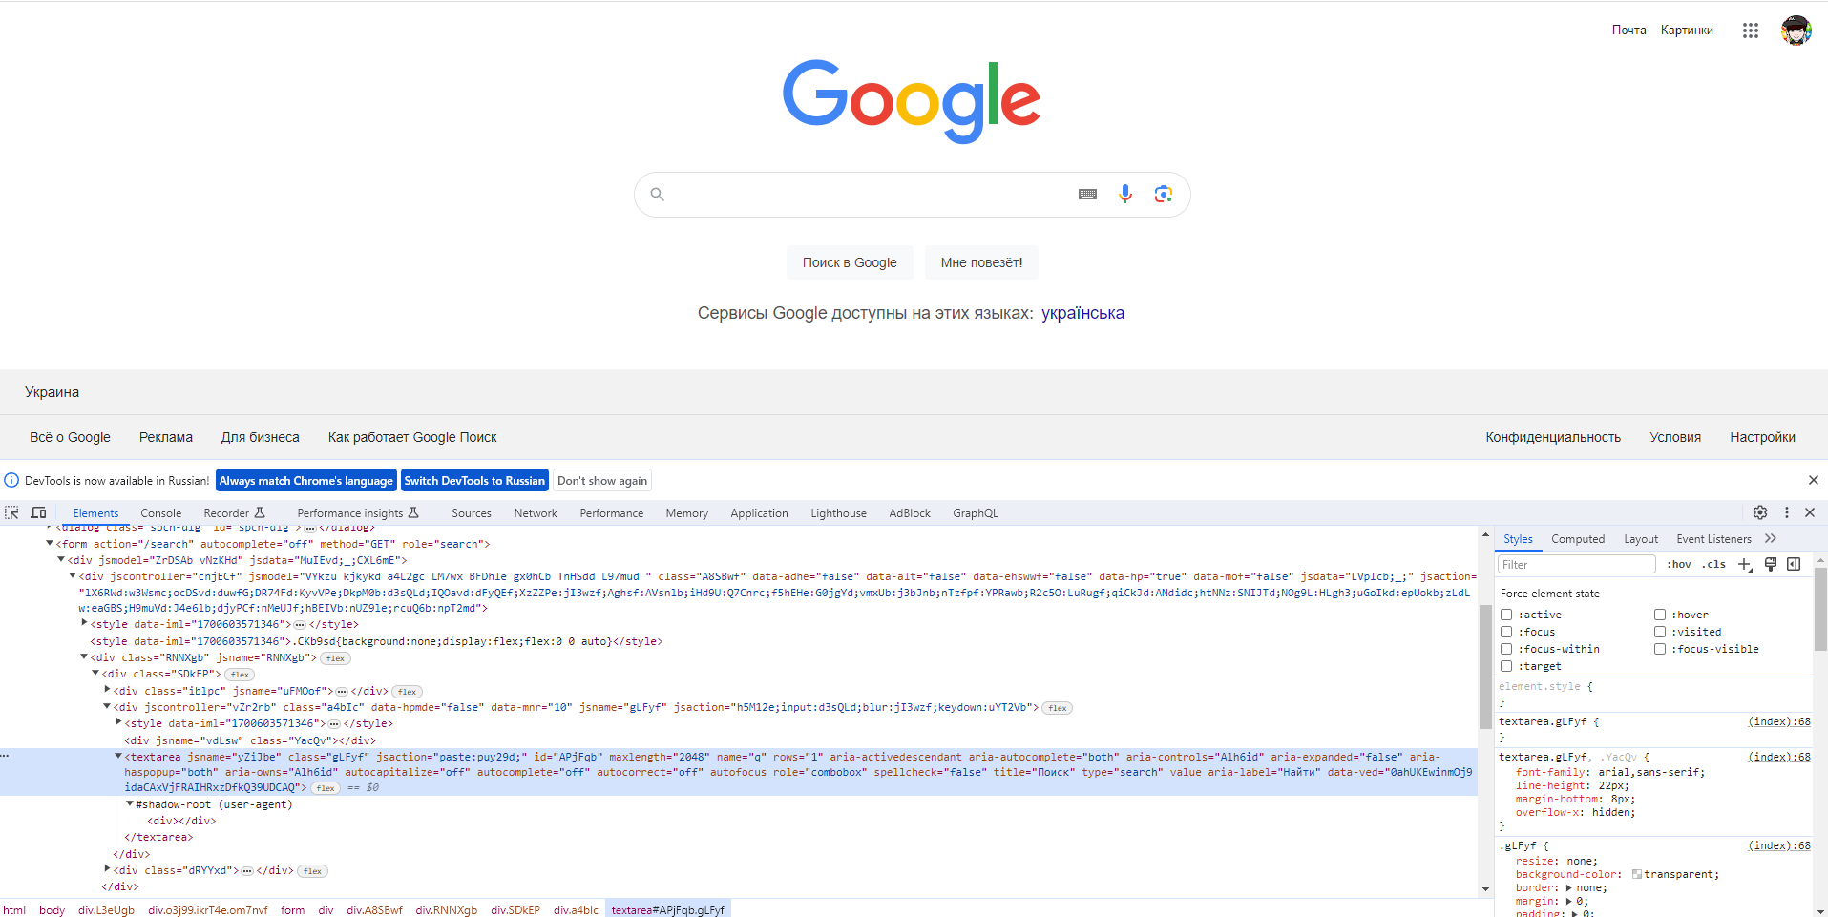

HTML

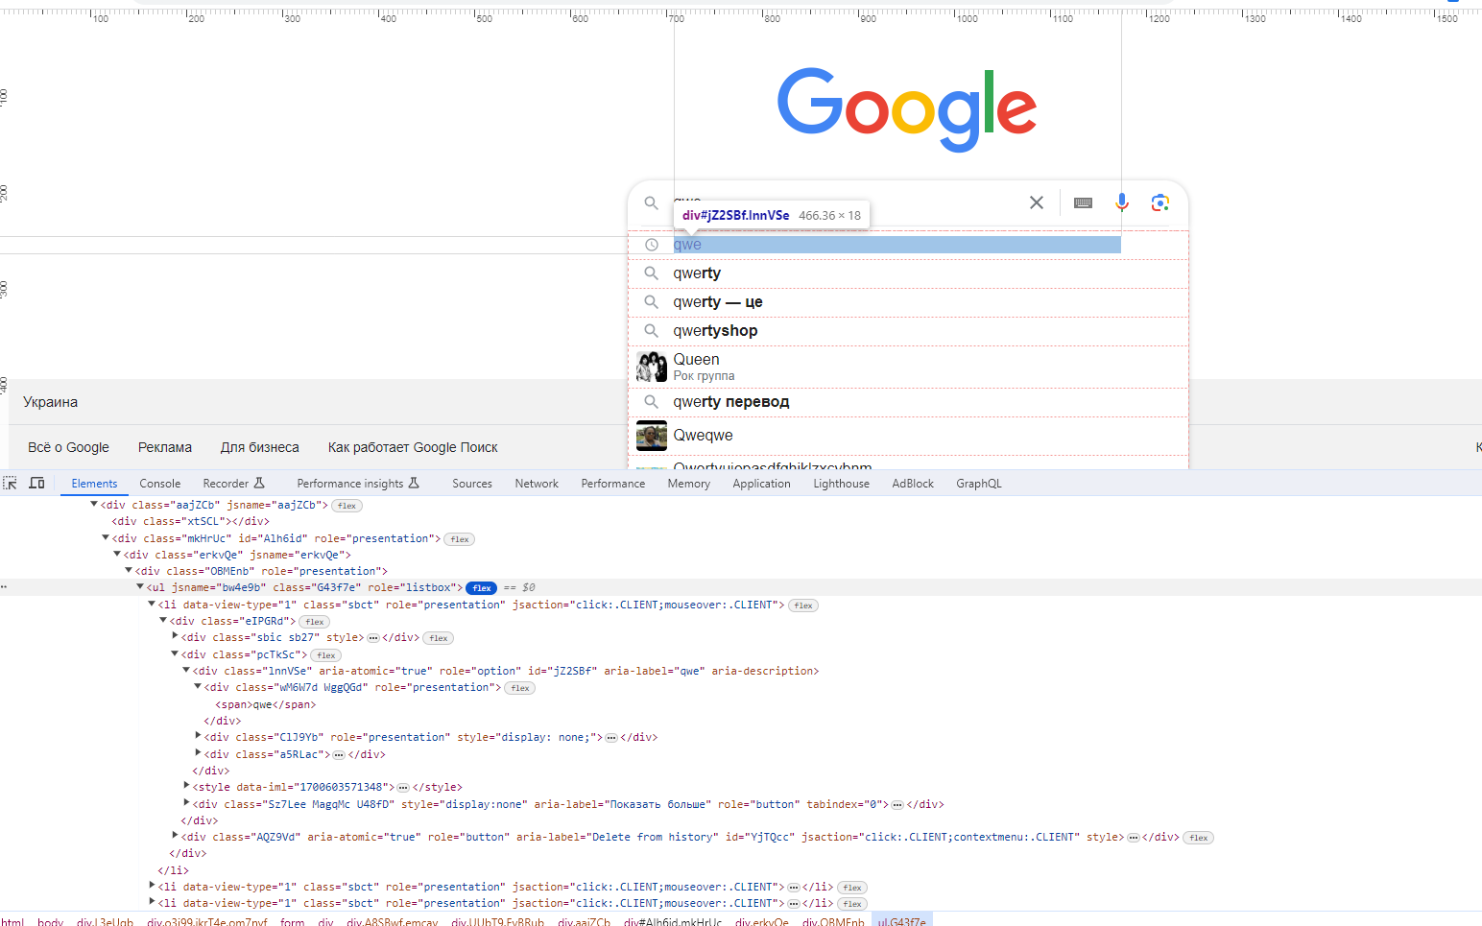

Евент лісенери для об’єкту:

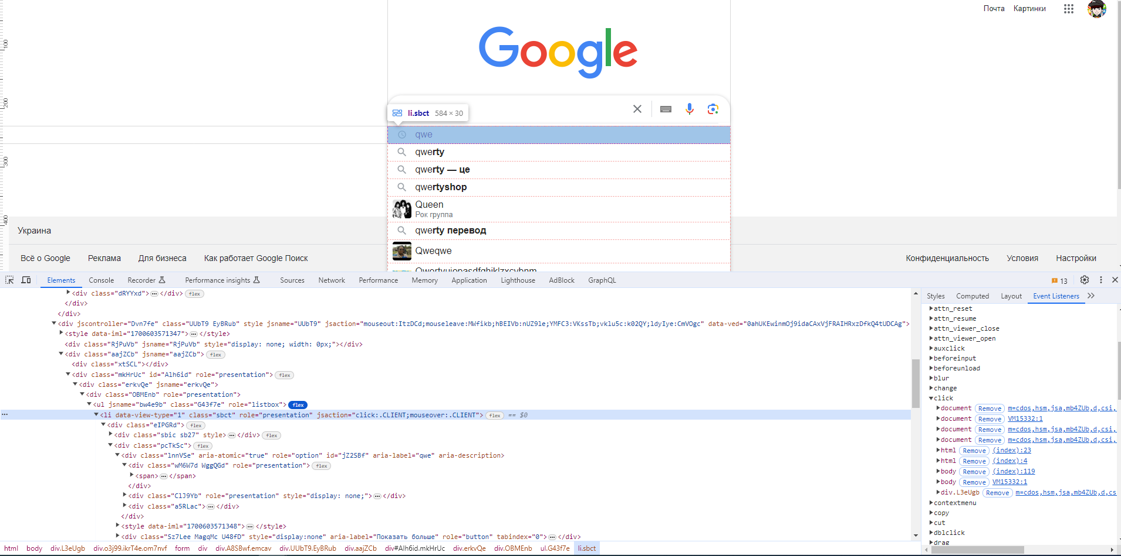

Через те, що серві використовує обфускатори – неможливо зрозуміти що виконує натискання на елемент списку 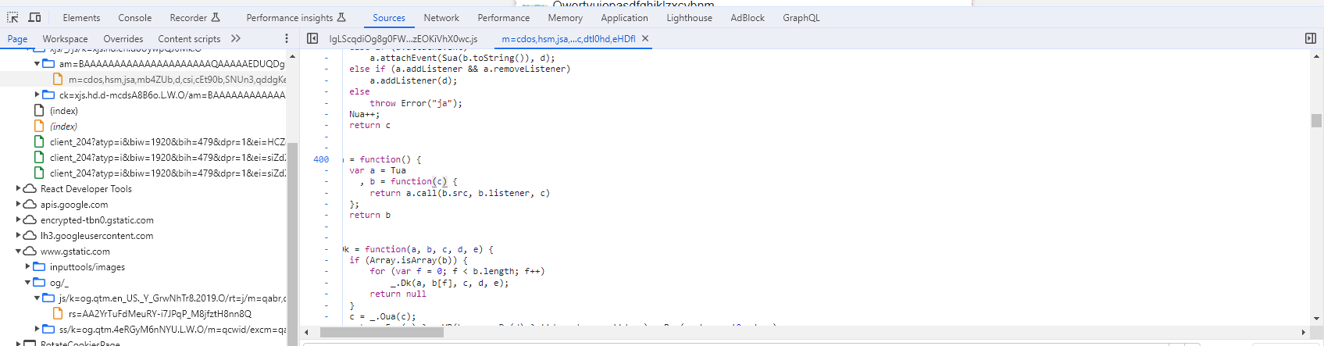

HTML:

<form action**="/search"** autocomplete**="off"** method**="GET"** role**="search"**>  
 <div jsmodel**="ZrDSAb vNzKHd"** jsdata**="MuIEvd;_;CXL6mE"**>  
 <div jscontroller**="cnjECf"** jsmodel**="VYkzu kjkykd a4L2gc LM7wx BFDhle gx0hCb TnHSdd L97mud "** class**="A8SBwf"** data-adhe**="false"** data-alt**="false"** data-ehswwf**="false"** data-hp**="true"** data-mof**="false"** jsdata**="LVplcb;_;"** jsaction**="lX6RWd:w3Wsmc;ocDSvd:duwfG;DR74Fd:KyvVPe;DkpM0b:d3sQLd;IQOavd:dFyQEf;XzZZPe:jI3wzf;Aghsf:AVsnlb;iHd9U:Q7Cnrc;f5hEHe:G0jgYd;vmxUb:j3bJnb;nTzfpf:YPRawb;R2c5O:LuRugf;qiCkJd:ANdidc;htNNz:SNIJTd;NOg9L:HLgh3;uGoIkd:epUokb;zLdLw:eaGBS;H9muVd:J4e6lb;djyPCf:nMeUJf;hBEIVb:nUZ9le;rcuQ6b:npT2md"**>  
 <div class**="RNNXgb"** jsname**="RNNXgb"**>  
 <div class**="SDkEP"**>  
 <div class**="iblpc"** jsname**="uFMOof"**>  
 <div class**="CcAdNb"**><span class**="QCzoEc z1asCe MZy1Rb"** style**="***height*:20**px**;*line-height*:20**px**;*width*:20**px"**><svg focusable**="false"** xmlns**="http://www.w3.org/2000/svg"** viewBox**="0 0 24 24"**><path  
 d**="M15.5 14h-.79l-.28-.27A6.471 6.471 0 0 0 16 9.5 6.5 6.5 0 1 0 9.5 16c1.61 0 3.09-.59 4.23-1.57l.27.28v.79l5 4.99L20.49 19l-4.99-5zm-6 0C7.01 14 5 11.99 5 9.5S7.01 5 9.5 5 14 7.01 14 9.5 11.99 14 9.5 14z"**></path></svg></span>  
 </div>  
 </div>  
 <div jscontroller**="vZr2rb"** class**="a4bIc"** data-hpmde**="false"** data-mnr**="10"** jsname**="gLFyf"** jsaction**="h5M12e;input:d3sQLd;blur:jI3wzf;keydown:uYT2Vb"**>  
 <div jsname**="vdLsw"** class**="YacQv"**></div>  
 <textarea jsname**="yZiJbe"** class**="gLFyf"** jsaction**="paste:puy29d;"** id**="APjFqb"** maxlength**="2048"** name**="q"** rows**="1"** aria-activedescendant**=""** aria-autocomplete**="both"** aria-controls**="Alh6id"** aria-expanded**="false"** aria-haspopup**="both"** aria-owns**="Alh6id"** autocapitalize**="off"** autocomplete**="off"** autocorrect**="off"** autofocus**=""** role**="combobox"** spellcheck**="false"** title**="Поиск"** type**="search"** value**=""** aria-label**="Найти"** data-ved**="0ahUKEwinmOj9idaCAxVjFRAIHRxzDfkQ39UDCAQ"** style**=""**></textarea></div>  
 <div class**="dRYYxd"**>  
 <div jscontroller**="PymCCe"** jsname**="RP0xob"** class**="BKRPef"**>  
 <div class**="vOY7J M2vV3"** tabindex**="0"** jsname**="pkjasb"** aria-label**="Очистить"** role**="button"** jsaction**="AVsnlb;rcuQ6b:npT2md"** data-ved**="0ahUKEwinmOj9idaCAxVjFRAIHRxzDfkQ05YFCAU"**>  
 <span class**="ExCKkf z1asCe rzyADb"** jsname**="itVqKe"**><svg focusable**="false"** xmlns**="http://www.w3.org/2000/svg"** viewBox**="0 0 24 24"**><path  
 d**="M19 6.41L17.59 5 12 10.59 6.41 5 5 6.41 10.59 12 5 17.59 6.41 19 12 13.41 17.59 19 19 17.59 13.41 12z"**></path></svg></span>  
 </div>  
 <span jsname**="s1VaRe"** class**="ACRAdd M2vV3"**></span></div>  
 <div jscontroller**="Y9t9Sc"** class**="Umvnrc"** aria-label**="Экранная клавиатура"** role**="button"** tabindex**="0"** jsaction**="h5M12e;rcuQ6b:npT2md"**><span class**="ly0Ckb"**><img class**="yAnw3c"** src**="/tia/tia.png"** tia_disable_swap**="true"** tia_field_name**="q"** jsname**="JyIpdf"** data-iml**="1700603571346"** data-atf**="0"** data-frt**="0"** tia_property**="web"**></span>  
 </div>  
 <div jscontroller**="unV4T"** jsname**="F7uqIe"** class**="XDyW0e"** aria-label**="Голосовой поиск"** role**="button"** tabindex**="0"** jsaction**="h5M12e;rcuQ6b:npT2md"** data-ved**="0ahUKEwinmOj9idaCAxVjFRAIHRxzDfkQvs8DCAY"**>  
 <svg class**="goxjub"** focusable**="false"** viewBox**="0 0 24 24"** xmlns**="http://www.w3.org/2000/svg"**>  
 <path fill**="#4285f4"** d**="m12 15c1.66 0 3-1.31 3-2.97v-7.02c0-1.66-1.34-3.01-3-3.01s-3 1.34-3 3.01v7.02c0 1.66 1.34 2.97 3 2.97z"**></path>  
 <path fill**="#34a853"** d**="m11 18.08h2v3.92h-2z"**></path>  
 <path fill**="#fbbc05"** d**="m7.05 16.87c-1.27-1.33-2.05-2.83-2.05-4.87h2c0 1.45 0.56 2.42 1.47 3.38v0.32l-1.15 1.18z"**></path>  
 <path fill**="#ea4335"** d**="m12 16.93a4.97 5.25 0 0 1 -3.54 -1.55l-1.41 1.49c1.26 1.34 3.02 2.13 4.95 2.13 3.87 0 6.99-2.92 6.99-7h-1.99c0 2.92-2.24 4.93-5 4.93z"**></path>  
 </svg>  
 </div>  
 <div jscontroller**="lpsUAf"** jsname**="R5mgy"** class**="nDcEnd"** data-base-lens-url**="https://lens.google.com"** data-image-processor-enabled**="true"** data-is-images-mode**="false"** data-preferred-mime-type**="image/jpeg"** data-propagated-experiment-ids**=""** aria-label**="Поиск по картинке"** role**="button"** tabindex**="0"** jsaction**="rcuQ6b:npT2md;h5M12e"** data-ved**="0ahUKEwinmOj9idaCAxVjFRAIHRxzDfkQhqEICAc"**>  
 <svg class**="Gdd5U"** focusable**="false"** viewBox**="0 0 192 192"** xmlns**="http://www.w3.org/2000/svg"**>  
 <rect fill**="none"** height**="192"** width**="192"**></rect>  
 <g>  
 <circle fill**="#34a853"** cx**="144.07"** cy**="144"** r**="16"**></circle>  
 <circle fill**="#4285f4"** cx**="96.07"** cy**="104"** r**="24"**></circle>  
 <path fill**="#ea4335"** d**="M24,135.2c0,18.11,14.69,32.8,32.8,32.8H96v-16l-40.1-0.1c-8.8,0-15.9-8.19-15.9-17.9v-18H24V135.2z"**></path>  
 <path fill**="#fbbc05"** d**="M168,72.8c0-18.11-14.69-32.8-32.8-32.8H116l20,16c8.8,0,16,8.29,16,18v30h16V72.8z"**></path>  
 <path fill**="#4285f4"** d**="M112,24l-32,0L68,40H56.8C38.69,40,24,54.69,24,72.8V92h16V74c0-9.71,7.2-18,16-18h80L112,24z"**></path>  
 </g>  
 </svg>  
 </div>  
 </div>  
 </div>  
 </div>  
 <div jscontroller**="Dvn7fe"** class**="UUbT9 EyBRub"** style**="***display*: **none**;**"** jsname**="UUbT9"** jsaction**="mouseout:ItzDCd;mouseleave:MWfikb;hBEIVb:nUZ9le;YMFC3:VKssTb;vklu5c:k02QY;ldyIye:CmVOgc"** data-ved**="0ahUKEwinmOj9idaCAxVjFRAIHRxzDfkQ4tUDCAg"**>  
 <div class**="RjPuVb"** jsname**="RjPuVb"** style**="***display*: **none**; *width*: 0**px**;**"**></div>  
 <div class**="aajZCb"** jsname**="aajZCb"**>  
 <div class**="xtSCL"**></div>  
 <div class**="mkHrUc"** id**="Alh6id"** role**="presentation"**>  
 <div class**="erkvQe"** jsname**="erkvQe"**>  
 <div class**="OBMEnb"** role**="presentation"**>  
 <ul jsname**="bw4e9b"** class**="G43f7e"** role**="listbox"**>  
 <li data-view-type**="1"** class**="sbct"** role**="presentation"** jsaction**="click:.CLIENT;mouseover:.CLIENT"**>  
 <div class**="eIPGRd"**>  
 <div class**="sbic sb27"** style**=""**>  
 <div class**="j0GJWd"** style**="***display*:**none"**>  
 <div><img class**="uHGFVd AZNDm"** alt**=""** style**="***display*:**none"** data-atf**="0"** data-frt**="0"**></div>  
 <div class**="iQxPRb"**><img class**="uHGFVd EOLKOc"** alt**=""** style**="***display*:**none"** data-atf**="0"** data-frt**="0"**><img class**="uHGFVd EOLKOc"** alt**=""** style**="***display*:**none"** data-atf**="0"** data-frt**="0"**></div>  
 </div>  
 </div>  
 <div class**="pcTkSc"**>  
 <div class**="lnnVSe"** aria-atomic**="true"** role**="option"** id**="jZ2SBf"** aria-label**="qwe"** aria-description**=""**>  
 <div class**="wM6W7d WggQGd"** role**="presentation"**><span>**qwe**</span>  
 </div>  
 <div class**="ClJ9Yb"** role**="presentation"** style**="***display*: **none**;**"**>  
 <span>**Порода собак**</span></div>  
 <div class**="a5RLac"**><span></span></div>  
 </div>  
 <div class**="Sz7Lee MagqMc U48fD"** style**="***display*:**none"** aria-label**="Показать больше"** role**="button"** tabindex**="0"**>  
 <hr class**="Bi9oQd"** aria-hidden**="true"**>  
 <div class**="ZFiwCf"**><span class**="LGwnxb"**>**Показать больше**</span><span  
 class**="w2fKdd z1asCe"** style**="***height*:20**px**;*line-height*:20**px**;*width*:20**px"**><svg  
 focusable**="false"** xmlns**="http://www.w3.org/2000/svg"** viewBox**="0 0 24 24"**><path  
 d**="M12 4l-1.41 1.41L16.17 11H4v2h12.17l-5.58 5.59L12 20l8-8z"**></path></svg></span>  
 </div>  
 </div>  
 </div>  
 <div class**="AQZ9Vd"** aria-atomic**="true"** role**="button"** aria-label**="Delete from history"** id**="YjTQcc"** jsaction**="click:.CLIENT;contextmenu:.CLIENT"** style**=""**>  
 <div class**="sbai JCHpcb"** role**="presentation"**>**Удалить**</div>  
 </div>  
 </div>  
 </li>  
 <li data-view-type**="1"** class**="sbct"** role**="presentation"** jsaction**="click:.CLIENT;mouseover:.CLIENT"**>  
 <div class**="eIPGRd"**>  
 <div class**="sbic sb43"** style**=""**>  
 <div class**="j0GJWd"** style**="***display*:**none"**>  
 <div><img class**="uHGFVd AZNDm"** alt**=""** style**="***display*:**none"** data-atf**="0"** data-frt**="0"**></div>  
 <div class**="iQxPRb"**><img class**="uHGFVd EOLKOc"** alt**=""** style**="***display*:**none"** data-atf**="0"** data-frt**="0"**><img class**="uHGFVd EOLKOc"** alt**=""** style**="***display*:**none"** data-atf**="0"** data-frt**="0"**></div>  
 </div>  
 </div>  
 <div class**="pcTkSc"**>  
 <div class**="lnnVSe"** aria-atomic**="true"** role**="option"** id**="ERWdKc"** aria-label**="qwerty"** aria-description**=""**>  
 <div class**="wM6W7d"** role**="presentation"**><span>**qwe**<b>**rty**</b></span>  
 </div>  
 <div class**="ClJ9Yb"** role**="presentation"** style**="***display*: **none**;**"**>  
 <span>**Телесериал**</span></div>  
 <div class**="a5RLac"**><span></span></div>  
 </div>  
 <div class**="Sz7Lee MagqMc U48fD"** style**="***display*:**none"** aria-label**="Показать больше"** role**="button"** tabindex**="0"**>  
 <hr class**="Bi9oQd"** aria-hidden**="true"**>  
 <div class**="ZFiwCf"**><span class**="LGwnxb"**>**Показать больше**</span><span  
 class**="w2fKdd z1asCe"** style**="***height*:20**px**;*line-height*:20**px**;*width*:20**px"**><svg  
 focusable**="false"** xmlns**="http://www.w3.org/2000/svg"** viewBox**="0 0 24 24"**><path  
 d**="M12 4l-1.41 1.41L16.17 11H4v2h12.17l-5.58 5.59L12 20l8-8z"**></path></svg></span>  
 </div>  
 </div>  
 </div>  
 <div class**="AQZ9Vd"** aria-atomic**="true"** role**="button"** aria-label**="Delete from history"** id**="W8tZub"** jsaction**=""** style**="***display*: **none**;**"**>  
 <div class**="sbai JCHpcb"** role**="presentation"**>**Удалить**</div>  
 </div>  
 </div>  
 </li>  
 <li data-view-type**="1"** class**="sbct"** role**="presentation"** jsaction**="click:.CLIENT;mouseover:.CLIENT"**>  
 <div class**="eIPGRd"**>  
 <div class**="sbic sb43"** style**=""**>  
 <div class**="j0GJWd"** style**="***display*:**none"**>  
 <div><img class**="uHGFVd AZNDm"** alt**=""** style**="***display*:**none"** data-atf**="0"** data-frt**="0"**></div>  
 <div class**="iQxPRb"**><img class**="uHGFVd EOLKOc"** alt**=""** style**="***display*:**none"** data-atf**="0"** data-frt**="0"**><img class**="uHGFVd EOLKOc"** alt**=""** style**="***display*:**none"** data-atf**="0"** data-frt**="0"**></div>  
 </div>  
 </div>  
 <div class**="pcTkSc"**>  
 <div class**="lnnVSe"** aria-atomic**="true"** role**="option"** id**="c7mM1c"** aria-label**="qwerty — це"** aria-description**=""**>  
 <div class**="wM6W7d"** role**="presentation"**>  
 <span>**qwe**<b>**rty — це**</b></span></div>  
 <div class**="ClJ9Yb"** role**="presentation"** style**="***display*: **none**;**"**>  
 <span>**Senior Secret Love — Телепрограмма**</span></div>  
 <div class**="a5RLac"**><span></span></div>  
 </div>  
 <div class**="Sz7Lee MagqMc U48fD"** style**="***display*:**none"** aria-label**="Показать больше"** role**="button"** tabindex**="0"**>  
 <hr class**="Bi9oQd"** aria-hidden**="true"**>  
 <div class**="ZFiwCf"**><span class**="LGwnxb"**>**Показать больше**</span><span  
 class**="w2fKdd z1asCe"** style**="***height*:20**px**;*line-height*:20**px**;*width*:20**px"**><svg  
 focusable**="false"** xmlns**="http://www.w3.org/2000/svg"** viewBox**="0 0 24 24"**><path  
 d**="M12 4l-1.41 1.41L16.17 11H4v2h12.17l-5.58 5.59L12 20l8-8z"**></path></svg></span>  
 </div>  
 </div>  
 </div>  
 <div class**="AQZ9Vd"** aria-atomic**="true"** role**="button"** aria-label**="Delete from history"** id**="imccif"** jsaction**=""** style**="***display*: **none**;**"**>  
 <div class**="sbai JCHpcb"** role**="presentation"**>**Удалить**</div>  
 </div>  
 </div>  
 </li>  
 <li data-view-type**="1"** class**="sbct"** role**="presentation"** jsaction**="click:.CLIENT;mouseover:.CLIENT"**>  
 <div class**="eIPGRd"**>  
 <div class**="sbic sb43"** style**=""**>  
 <div class**="j0GJWd"** style**="***display*:**none"**>  
 <div><img class**="uHGFVd AZNDm"** alt**=""** style**="***display*:**none"** data-atf**="0"** data-frt**="0"**></div>  
 <div class**="iQxPRb"**><img class**="uHGFVd EOLKOc"** alt**=""** style**="***display*:**none"** data-atf**="0"** data-frt**="0"**><img class**="uHGFVd EOLKOc"** alt**=""** style**="***display*:**none"** data-atf**="0"** data-frt**="0"**></div>  
 </div>  
 </div>  
 <div class**="pcTkSc"**>  
 <div class**="lnnVSe"** aria-atomic**="true"** role**="option"** id**="Zrbbw"** aria-label**="qwertyshop"** aria-description**=""**>  
 <div class**="wM6W7d"** role**="presentation"**>  
 <span>**qwe**<b>**rtyshop**</b></span></div>  
 <div class**="ClJ9Yb"** role**="presentation"** style**="***display*: **none**;**"**>  
 <span>**Senior Secret Love — Телепрограмма**</span></div>  
 <div class**="a5RLac"**><span></span></div>  
 </div>  
 <div class**="Sz7Lee MagqMc U48fD"** style**="***display*:**none"** aria-label**="Показать больше"** role**="button"** tabindex**="0"**>  
 <hr class**="Bi9oQd"** aria-hidden**="true"**>  
 <div class**="ZFiwCf"**><span class**="LGwnxb"**>**Показать больше**</span><span  
 class**="w2fKdd z1asCe"** style**="***height*:20**px**;*line-height*:20**px**;*width*:20**px"**><svg  
 focusable**="false"** xmlns**="http://www.w3.org/2000/svg"** viewBox**="0 0 24 24"**><path  
 d**="M12 4l-1.41 1.41L16.17 11H4v2h12.17l-5.58 5.59L12 20l8-8z"**></path></svg></span>  
 </div>  
 </div>  
 </div>  
 <div class**="AQZ9Vd"** aria-atomic**="true"** role**="button"** aria-label**="Delete from history"** id**="E8uKpd"** jsaction**=""** style**="***display*: **none**;**"**>  
 <div class**="sbai JCHpcb"** role**="presentation"**>**Удалить**</div>  
 </div>  
 </div>  
 </li>  
 <li data-view-type**="1"** class**="sbct sbre"** role**="presentation"** jsaction**="click:.CLIENT;mouseover:.CLIENT"**>  
 <div class**="eIPGRd"**>  
 <div class**="sbic vYOkbe"** data-src**="https://encrypted-tbn0.gstatic.com/images?q=tbn:ANd9GcRGur0mRExVuB0jmLlD4mN6qEGj2CT8A-XYTEOneC_AXiVUlaiZa3LvChIH&amp;s=10"** style**="***background-image*: url(*&quot;https://encrypted-tbn0.gstatic.com/images?q=tbn:ANd9GcRGur0mRExVuB0jmLlD4mN6qEGj2CT8A-XYTEOneC_AXiVUlaiZa3LvChIH&amp;s=10&quot;*);**"**>  
 <div class**="j0GJWd"** style**="***display*:**none"**>  
 <div><img class**="uHGFVd AZNDm"** alt**=""** style**="***display*:**none"** data-atf**="0"** data-frt**="0"**></div>  
 <div class**="iQxPRb"**><img class**="uHGFVd EOLKOc"** alt**=""** style**="***display*:**none"** data-atf**="0"** data-frt**="0"**><img class**="uHGFVd EOLKOc"** alt**=""** style**="***display*:**none"** data-atf**="0"** data-frt**="0"**></div>  
 </div>  
 </div>  
 <div class**="pcTkSc"**>  
 <div class**="lnnVSe"** aria-atomic**="true"** role**="option"** id**="sBQTL"** aria-label**="queen"** aria-description**="Рок группа"**>  
 <div class**="wM6W7d"** role**="presentation"**><span>**Queen**</span></div>  
 <div class**="ClJ9Yb"** role**="presentation"** style**=""**>  
 <span>**Рок группа**</span></div>  
 <div class**="a5RLac"**><span></span></div>  
 </div>  
 <div class**="Sz7Lee MagqMc U48fD"** style**="***display*:**none"** aria-label**="Показать больше"** role**="button"** tabindex**="0"**>  
 <hr class**="Bi9oQd"** aria-hidden**="true"**>  
 <div class**="ZFiwCf"**><span class**="LGwnxb"**>**Показать больше**</span><span  
 class**="w2fKdd z1asCe"** style**="***height*:20**px**;*line-height*:20**px**;*width*:20**px"**><svg  
 focusable**="false"** xmlns**="http://www.w3.org/2000/svg"** viewBox**="0 0 24 24"**><path  
 d**="M12 4l-1.41 1.41L16.17 11H4v2h12.17l-5.58 5.59L12 20l8-8z"**></path></svg></span>  
 </div>  
 </div>  
 </div>  
 <div class**="AQZ9Vd"** aria-atomic**="true"** role**="button"** aria-label**="Delete from history"** id**="pca44c"** jsaction**=""** style**="***display*: **none**;**"**>  
 <div class**="sbai JCHpcb"** role**="presentation"**>**Удалить**</div>  
 </div>  
 </div>  
 </li>  
 <li data-view-type**="1"** class**="sbct"** role**="presentation"** jsaction**="click:.CLIENT;mouseover:.CLIENT"**>  
 <div class**="eIPGRd"**>  
 <div class**="sbic sb43"**>  
 <div class**="j0GJWd"** style**="***display*:**none"**>  
 <div><img class**="uHGFVd AZNDm"** alt**=""** style**="***display*:**none"** data-atf**="0"** data-frt**="0"**></div>  
 <div class**="iQxPRb"**><img class**="uHGFVd EOLKOc"** alt**=""** style**="***display*:**none"** data-atf**="0"** data-frt**="0"**><img class**="uHGFVd EOLKOc"** alt**=""** style**="***display*:**none"** data-atf**="0"** data-frt**="0"**></div>  
 </div>  
 </div>  
 <div class**="pcTkSc"**>  
 <div class**="lnnVSe"** aria-atomic**="true"** role**="option"** id**="vTtioc"** aria-label**="qwerty перевод"** aria-description**=""**>  
 <div class**="wM6W7d"** role**="presentation"**><span>**qwe**<b>**rty перевод**</b></span>  
 </div>  
 <div class**="ClJ9Yb"** role**="presentation"** style**="***display*: **none**;**"**>  
 <span></span></div>  
 <div class**="a5RLac"**><span></span></div>  
 </div>  
 <div class**="Sz7Lee MagqMc U48fD"** style**="***display*:**none"** aria-label**="Показать больше"** role**="button"** tabindex**="0"**>  
 <hr class**="Bi9oQd"** aria-hidden**="true"**>  
 <div class**="ZFiwCf"**><span class**="LGwnxb"**>**Показать больше**</span><span  
 class**="w2fKdd z1asCe"** style**="***height*:20**px**;*line-height*:20**px**;*width*:20**px"**><svg  
 focusable**="false"** xmlns**="http://www.w3.org/2000/svg"** viewBox**="0 0 24 24"**><path  
 d**="M12 4l-1.41 1.41L16.17 11H4v2h12.17l-5.58 5.59L12 20l8-8z"**></path></svg></span>  
 </div>  
 </div>  
 </div>  
 <div class**="AQZ9Vd"** aria-atomic**="true"** role**="button"** aria-label**="Delete from history"** id**="qaHVrc"** jsaction**=""** style**="***display*: **none**;**"**>  
 <div class**="sbai JCHpcb"** role**="presentation"**>**Удалить**</div>  
 </div>  
 </div>  
 </li>  
 <li data-view-type**="1"** class**="sbct sbre"** role**="presentation"** jsaction**="click:.CLIENT;mouseover:.CLIENT"**>  
 <div class**="eIPGRd"**>  
 <div class**="sbic vYOkbe"** style**="***background-image*: url(*&quot;https://encrypted-tbn0.gstatic.com/images?q=tbn:ANd9GcQHI_wenieeQvlQ5RlP4Was_5ocIic1nn8RsGKv38uSbsbuGPFPOeKQCwQ&amp;s=10&quot;*);**"** data-src**="https://encrypted-tbn0.gstatic.com/images?q=tbn:ANd9GcQHI_wenieeQvlQ5RlP4Was_5ocIic1nn8RsGKv38uSbsbuGPFPOeKQCwQ&amp;s=10"**>  
 <div class**="j0GJWd"** style**="***display*:**none"**>  
 <div><img class**="uHGFVd AZNDm"** alt**=""** style**="***display*:**none"** data-atf**="0"** data-frt**="0"**></div>  
 <div class**="iQxPRb"**><img class**="uHGFVd EOLKOc"** alt**=""** style**="***display*:**none"** data-atf**="0"** data-frt**="0"**><img class**="uHGFVd EOLKOc"** alt**=""** style**="***display*:**none"** data-atf**="0"** data-frt**="0"**></div>  
 </div>  
 </div>  
 <div class**="pcTkSc"**>  
 <div class**="lnnVSe"** aria-atomic**="true"** role**="option"** id**="gLuoSb"** aria-label**="йцуйцу"** aria-description**=""**>  
 <div class**="wM6W7d"** role**="presentation"**><span>**Qweqwe**</span></div>  
 <div class**="ClJ9Yb"** role**="presentation"** style**="***display*: **none**;**"**>  
 <span>**Трек – (G)I-dle**</span></div>  
 <div class**="a5RLac"**><span></span></div>  
 </div>  
 <div class**="Sz7Lee MagqMc U48fD"** style**="***display*:**none"** aria-label**="Показать больше"** role**="button"** tabindex**="0"**>  
 <hr class**="Bi9oQd"** aria-hidden**="true"**>  
 <div class**="ZFiwCf"**><span class**="LGwnxb"**>**Показать больше**</span><span  
 class**="w2fKdd z1asCe"** style**="***height*:20**px**;*line-height*:20**px**;*width*:20**px"**><svg  
 focusable**="false"** xmlns**="http://www.w3.org/2000/svg"** viewBox**="0 0 24 24"**><path  
 d**="M12 4l-1.41 1.41L16.17 11H4v2h12.17l-5.58 5.59L12 20l8-8z"**></path></svg></span>  
 </div>  
 </div>  
 </div>  
 <div class**="AQZ9Vd"** aria-atomic**="true"** role**="button"** aria-label**="Delete from history"** id**="BYQWoc"** jsaction**=""** style**="***display*: **none**;**"**>  
 <div class**="sbai JCHpcb"** role**="presentation"**>**Удалить**</div>  
 </div>  
 </div>  
 </li>  
 <li data-view-type**="1"** class**="sbct sbre"** role**="presentation"** jsaction**="click:.CLIENT;mouseover:.CLIENT"**>  
 <div class**="eIPGRd"**>  
 <div class**="sbic vYOkbe"** style**="***background-image*: url(*&quot;https://encrypted-tbn0.gstatic.com/images?q=tbn:ANd9GcR862OgCwSelHMqKXKBz8_tkQMxueNlcjsczcY7Qnw&amp;s=10&quot;*);**"** data-src**="https://encrypted-tbn0.gstatic.com/images?q=tbn:ANd9GcR862OgCwSelHMqKXKBz8_tkQMxueNlcjsczcY7Qnw&amp;s=10"**>  
 <div class**="j0GJWd"** style**="***display*:**none"**>  
 <div><img class**="uHGFVd AZNDm"** alt**=""** style**="***display*:**none"** data-atf**="0"** data-frt**="0"**></div>  
 <div class**="iQxPRb"**><img class**="uHGFVd EOLKOc"** alt**=""** style**="***display*:**none"** data-atf**="0"** data-frt**="0"**><img class**="uHGFVd EOLKOc"** alt**=""** style**="***display*:**none"** data-atf**="0"** data-frt**="0"**></div>  
 </div>  
 </div>  
 <div class**="pcTkSc"**>  
 <div class**="lnnVSe"** aria-atomic**="true"** role**="option"** id**="mdzGzd"** aria-label**="qwertyuiopasdfghjklzxcvbnm"** aria-description**="Трек"**>  
 <div class**="wM6W7d"** role**="presentation"**><span>**Qwertyuiopasdfghjklzxcvbnm**</span>  
 </div>  
 <div class**="ClJ9Yb"** role**="presentation"** style**=""**><span>**Трек**</span>  
 </div>  
 <div class**="a5RLac"**><span></span></div>  
 </div>  
 <div class**="Sz7Lee MagqMc U48fD"** style**="***display*:**none"** aria-label**="Показать больше"** role**="button"** tabindex**="0"**>  
 <hr class**="Bi9oQd"** aria-hidden**="true"**>  
 <div class**="ZFiwCf"**><span class**="LGwnxb"**>**Показать больше**</span><span  
 class**="w2fKdd z1asCe"** style**="***height*:20**px**;*line-height*:20**px**;*width*:20**px"**><svg  
 focusable**="false"** xmlns**="http://www.w3.org/2000/svg"** viewBox**="0 0 24 24"**><path  
 d**="M12 4l-1.41 1.41L16.17 11H4v2h12.17l-5.58 5.59L12 20l8-8z"**></path></svg></span>  
 </div>  
 </div>  
 </div>  
 <div class**="AQZ9Vd"** aria-atomic**="true"** role**="button"** aria-label**="Delete from history"** id**="w6uf9d"** jsaction**=""** style**="***display*: **none**;**"**>  
 <div class**="sbai JCHpcb"** role**="presentation"**>**Удалить**</div>  
 </div>  
 </div>  
 </li>  
 <li data-view-type**="1"** class**="sbct"** role**="presentation"** jsaction**="click:.CLIENT;mouseover:.CLIENT"**>  
 <div class**="eIPGRd"**>  
 <div class**="sbic sb43"** style**=""**>  
 <div class**="j0GJWd"** style**="***display*:**none"**>  
 <div><img class**="uHGFVd AZNDm"** alt**=""** style**="***display*:**none"** data-atf**="0"** data-frt**="0"**></div>  
 <div class**="iQxPRb"**><img class**="uHGFVd EOLKOc"** alt**=""** style**="***display*:**none"** data-atf**="0"** data-frt**="0"**><img class**="uHGFVd EOLKOc"** alt**=""** style**="***display*:**none"** data-atf**="0"** data-frt**="0"**></div>  
 </div>  
 </div>  
 <div class**="pcTkSc"**>  
 <div class**="lnnVSe"** aria-atomic**="true"** role**="option"** id**="hwdq1"** aria-label**="qwerty клавиатура"** aria-description**=""**>  
 <div class**="wM6W7d"** role**="presentation"**>  
 <span>**qwe**<b>**rty клавиатура**</b></span></div>  
 <div class**="ClJ9Yb"** role**="presentation"** style**="***display*: **none**;**"**>  
 <span>**Трек**</span></div>  
 <div class**="a5RLac"**><span></span></div>  
 </div>  
 <div class**="Sz7Lee MagqMc U48fD"** style**="***display*:**none"** aria-label**="Показать больше"** role**="button"** tabindex**="0"**>  
 <hr class**="Bi9oQd"** aria-hidden**="true"**>  
 <div class**="ZFiwCf"**><span class**="LGwnxb"**>**Показать больше**</span><span  
 class**="w2fKdd z1asCe"** style**="***height*:20**px**;*line-height*:20**px**;*width*:20**px"**><svg  
 focusable**="false"** xmlns**="http://www.w3.org/2000/svg"** viewBox**="0 0 24 24"**><path  
 d**="M12 4l-1.41 1.41L16.17 11H4v2h12.17l-5.58 5.59L12 20l8-8z"**></path></svg></span>  
 </div>  
 </div>  
 </div>  
 <div class**="AQZ9Vd"** aria-atomic**="true"** role**="button"** aria-label**="Delete from history"** id**="uG34ge"** jsaction**=""** style**="***display*: **none**;**"**>  
 <div class**="sbai JCHpcb"** role**="presentation"**>**Удалить**</div>  
 </div>  
 </div>  
 </li>  
 <li data-view-type**="1"** class**="sbct sbre"** role**="presentation"** jsaction**="click:.CLIENT;mouseover:.CLIENT"**>  
 <div class**="eIPGRd"**>  
 <div class**="sbic sb43"**>  
 <div class**="j0GJWd"** style**="***display*:**none"**>  
 <div><img class**="uHGFVd AZNDm"** alt**=""** style**="***display*:**none"** data-atf**="0"** data-frt**="0"**></div>  
 <div class**="iQxPRb"**><img class**="uHGFVd EOLKOc"** alt**=""** style**="***display*:**none"** data-atf**="0"** data-frt**="0"**><img class**="uHGFVd EOLKOc"** alt**=""** style**="***display*:**none"** data-atf**="0"** data-frt**="0"**></div>  
 </div>  
 </div>  
 <div class**="pcTkSc"**>  
 <div class**="lnnVSe"** aria-atomic**="true"** role**="option"** id**="HFKcI"** aria-label**="qwer"** aria-description**="Трек – Газо"**>  
 <div class**="wM6W7d"** role**="presentation"**><span>**Qwer**</span></div>  
 <div class**="ClJ9Yb"** role**="presentation"** style**=""**>  
 <span>**Трек – Газо**</span></div>  
 <div class**="a5RLac"**><span></span></div>  
 </div>  
 <div class**="Sz7Lee MagqMc U48fD"** style**="***display*:**none"** aria-label**="Показать больше"** role**="button"** tabindex**="0"**>  
 <hr class**="Bi9oQd"** aria-hidden**="true"**>  
 <div class**="ZFiwCf"**><span class**="LGwnxb"**>**Показать больше**</span><span  
 class**="w2fKdd z1asCe"** style**="***height*:20**px**;*line-height*:20**px**;*width*:20**px"**><svg  
 focusable**="false"** xmlns**="http://www.w3.org/2000/svg"** viewBox**="0 0 24 24"**><path  
 d**="M12 4l-1.41 1.41L16.17 11H4v2h12.17l-5.58 5.59L12 20l8-8z"**></path></svg></span>  
 </div>  
 </div>  
 </div>  
 <div class**="AQZ9Vd"** aria-atomic**="true"** role**="button"** aria-label**="Delete from history"** id**="Qd9eyc"** jsaction**=""** style**="***display*: **none**;**"**>  
 <div class**="sbai JCHpcb"** role**="presentation"**>**Удалить**</div>  
 </div>  
 </div>  
 </li>  
 </ul>  
 </div>  
 </div>  
 <div class**="rLrQHf"** jsname**="tovEib"** role**="presentation"**></div>  
 </div>  
 <div jsname**="E80e9e"** class**="OBMEnb"** id**="shJ2Vb"** role**="presentation"**>  
 <ul jsname**="bw4e9b"** class**="G43f7e"** role**="listbox"**></ul>  
 </div>  
 <div jsname**="XiTF2e"** class**="OBMEnb"** role**="presentation"**>  
 <div jsname**="Q7Erhd"** class**="G43f7e"** role**="presentation"**></div>  
 </div>  
 <div class**="ynRric"** id**="ynRric"** role**="presentation"**></div>  
 <li data-view-type**="1"** class**="sbct"** id**="YMXe"** role**="presentation"**>  
 <div class**="eIPGRd"**>  
 <div class**="sbic"**>  
 <div class**="j0GJWd"** style**="***display*:**none"**>  
 <div><img class**="uHGFVd AZNDm"** alt**=""** style**="***display*:**none"** data-atf**="0"** data-frt**="0"**></div>  
 <div class**="iQxPRb"**><img class**="uHGFVd EOLKOc"** alt**=""** style**="***display*:**none"** data-atf**="0"** data-frt**="0"**><img class**="uHGFVd EOLKOc"** alt**=""** style**="***display*:**none"** data-atf**="0"** data-frt**="0"**>  
 </div>  
 </div>  
 </div>  
 <div class**="pcTkSc"**>  
 <div class**="lnnVSe"** aria-atomic**="true"** role**="option"**>  
 <div class**="wM6W7d"**><span></span></div>  
 <div class**="ClJ9Yb"**><span></span></div>  
 <div class**="a5RLac"**><span></span></div>  
 </div>  
 <div class**="Sz7Lee MagqMc U48fD"** style**="***display*:**none"** aria-label**="Показать больше"** role**="button"** tabindex**="0"**>  
 <hr class**="Bi9oQd"** aria-hidden**="true"**>  
 <div class**="ZFiwCf"**><span class**="LGwnxb"**>**Показать больше**</span><span  
 class**="w2fKdd z1asCe"** style**="***height*:20**px**;*line-height*:20**px**;*width*:20**px"**><svg  
 focusable**="false"** xmlns**="http://www.w3.org/2000/svg"** viewBox**="0 0 24 24"**><path  
 d**="M12 4l-1.41 1.41L16.17 11H4v2h12.17l-5.58 5.59L12 20l8-8z"**></path></svg></span>  
 </div>  
 </div>  
 </div>  
 <div class**="AQZ9Vd"** aria-atomic**="true"** role**="button"**>  
 <div class**="sbai"** role**="presentation"**>**Удалить**</div>  
 </div>  
 </div>  
 </li>  
 <li data-view-type**="8"** class**="sbct"** id**="mitGyb"** role**="presentation"**>  
 <div class**="eIPGRd"**>  
 <div class**="sbic"**></div>  
 <div class**="pcTkSc"**>  
 <div aria-atomic**="true"** class**="lnnVSe"** role**="option"**>  
 <div class**="wM6W7d s2Wjec"**><span></span></div>  
 <div class**="ClJ9Yb"**><span></span></div>  
 </div>  
 </div>  
 <div class**="AQZ9Vd"** aria-atomic**="true"** role**="button"**>  
 <div class**="sbai"** role**="presentation"**>**Удалить**</div>  
 </div>  
 </div>  
 </li>  
 <div jsname**="VlcLAe"** class**="lJ9FBc"**>  
 <center><input class**="gNO89b"** value**="Поиск в Google"** aria-label**="Поиск в Google"** name**="btnK"** role**="button"** tabindex**="0"** type**="submit"** data-ved**="0ahUKEwinmOj9idaCAxVjFRAIHRxzDfkQ4dUDCAo"**> <input class**="RNmpXc"** value**="Мне повезёт!"** aria-label**="Мне повезёт!"** name**="btnI"** type**="submit"** jsaction**="trigger.kWlxhc"** data-ved**="0ahUKEwinmOj9idaCAxVjFRAIHRxzDfkQ19QECAs"**>  
 </center>  
 </div>  
 </div>  
 <div jscontroller**="OqGDve"** jsname**="JUypV"** style**=""**>  
 <div class**="MG7lrf"** jsname**="kAiEt"** data-async-context**="async_id:duf3-46;authority:0;card_id:;entry_point:0;feature_id:;ftoe:0;header:0;is_jobs_spam_form:0;open:0;preselect_answer_index:-1;suggestions:qwerty~!qwerty%20%E2%80%94%20%D1%86%D0%B5~!qwertyshop~!qwerty%20%D0%BF%D0%B5%D1%80%D0%B5%D0%B2%D0%BE%D0%B4~!qwertyuiopasdfghjklzxcvbnm~!qwerty%20%D0%BA%D0%BB%D0%B0%D0%B2%D0%B8%D0%B0%D1%82%D1%83%D1%80%D0%B0~!qwer;suggestions_subtypes:512,512,512,512,512,512,512;suggestions_types:0,0,0,0,46,0,46;surface:0;title:;type:46"**>  
  
 <div jscontroller**="EkevXb"** style**="***display*:**none"** jsaction**="rcuQ6b:npT2md"**></div>  
 <div id**="duf3-46"** data-jiis**="up"** data-async-type**="duffy3"** data-async-context-required**="type,open,feature_id,async_id,entry_point,authority,card_id,ftoe,title,header,suggestions,surface,suggestions_types,suggestions_subtypes,preselect_answer_index,is_jobs_spam_form"** class**="yp"** data-ved**="0ahUKEwinmOj9idaCAxVjFRAIHRxzDfkQ-0EIDA"**></div>  
 <a class**="oBa0Fe aciXEb"** href**="#"** id**="sbfblt"** data-async-trigger**="duf3-46"** aria-label**="Оставить отзыв об этом результате"** role**="button"** jsaction**="trigger.szjOR"** data-ved**="0ahUKEwinmOj9idaCAxVjFRAIHRxzDfkQtw8IDQ"**>**Пожаловаться на неприемлемые подсказки**</a>  
 </div>  
 </div>  
  
 <div class**="KxWPre"** id**="TWnylf"**>  
 <div class**="E2ShOd"**></div>  
 <span class**="VUsake"**></span>  
  
 <g-dropdown-menu class**="V7WNjc"** jscontroller**="pFsdhd"** jsdata**="xJGXK;_;CXL6mI"** jsshadow**=""** jsaction**="rcuQ6b:npT2md;mMf61e:GKlhgf;YraOve:cCpuJc;kNOP9c:bzkPEc;hmb6Ye:oyYkKb;KyPa0e:G8Ofmd;wjOG7e:rWoVB;ZvRO4b:L76sMb;LyWNEf:L76sMb"**>  
 <g-popup jsname**="zpo2ue"** jscontroller**="DPreE"** jsaction**="A05xBd:IYtByb;EOZ57e:WFrRFb;"** jsdata**="mVjAjf;_;CXL6mM"** id**="ow19"** __is_owner**="true"**>  
 <div jsname**="oYxtQd"** class**="CcNe6e"** aria-expanded**="false"** aria-haspopup**="true"** jsslot**=""** role**="button"** tabindex**="0"** aria-label**="Показать больше"** jsaction**="WFrRFb;keydown:uYT2Vb"**>  
 <div class**="wSGdUc"**><span class**="IjabWd z1asCe SaPW2b"**><svg focusable**="false"** xmlns**="http://www.w3.org/2000/svg"** viewBox**="0 0 24 24"**><path  
 d**="M12 8c1.1 0 2-.9 2-2s-.9-2-2-2-2 .9-2 2 .9 2 2 2zm0 2c-1.1 0-2 .9-2 2s.9 2 2 2 2-.9 2-2-.9-2-2-2zm0 6c-1.1 0-2 .9-2 2s.9 2 2 2 2-.9 2-2-.9-2-2-2z"**></path></svg></span>  
 </div>  
 </div>  
 <div jsname**="V68bde"** class**="UjBGL pkWBse iRQHZe"** style**="***display*:**none**;*z-index*:1000**"** jsowner**="ow19"**>  
 <g-menu jsname**="iXXGtd"** class**="WNN1b Shjy3b yTik0 wplJBd PBn44e iQXTJe"** jscontroller**="WlNQGd"** role**="menu"** tabindex**="-1"** jsaction**="PSl28c;focus:h06R8;keydown:uYT2Vb;mouseenter:WOQqYb;mouseleave:Tx5Rb;mouseover:IgJl9c"**>  
 <g-menu-item jsname**="NNJLud"** class**="GuoVP EpPYLd GZnQqe"** jscontroller**="CnSW2d"** role**="menuitem"** tabindex**="0"** data-short-label**=""** jsdata**="zPXzie;_;CXL6mQ"**>  
 <div jsname**="ibnC6b"** class**="YpcDnf OSrXXb"**>**Закрыть**</div>  
 </g-menu-item>  
 </g-menu>  
 </div>  
 </g-popup>  
 </g-dropdown-menu>  
 </div>  
  
 <div class**="zs1JGd"** data-view-type**="7"** jsname**="RqJ7oe"** id**="dh215c"** role**="presentation"**>  
 <div class**="JqPLlb"** role**="option"** tabindex**="0"**></div>  
 </div>  
 </div>  
 <div jsname**="mvaK7d"** class**="M8H8pb"** data-ved**="0ahUKEwinmOj9idaCAxVjFRAIHRxzDfkQ4d8ICBE"**></div>  
 <div class**="FPdoLc lJ9FBc"**>  
 <center><input class**="gNO89b"** value**="Поиск в Google"** aria-label**="Поиск в Google"** name**="btnK"** role**="button"** tabindex**="0"** type**="submit"** data-ved**="0ahUKEwinmOj9idaCAxVjFRAIHRxzDfkQ4dUDCBI"**> <input class**="RNmpXc"** value**="Мне повезёт!"** aria-label**="Мне повезёт!"** name**="btnI"** type**="submit"** jsaction**="trigger.kWlxhc"** data-ved**="0ahUKEwinmOj9idaCAxVjFRAIHRxzDfkQ19QECBM"**>  
 </center>  
 </div>  
 </div>  
 <div style**="***background*:url(*/images/searchbox/desktop_searchbox_sprites318_hr.webp*)**"**></div>  
 </div>  
 <div id**="tophf"**><input name**="sca_esv"** value**="584400697"** type**="hidden"**><input name**="sxsrf"** value**="AM9HkKmVe-ejV_6VscWJVvme--v631eF-A:1700603570599"** type**="hidden"**><input name**="source"** type**="hidden"** value**="hp"**><input  
 value**="siZdZaf3IeOqwPAPnOa1yA8"** name**="ei"** type**="hidden"**>  
 <input value**="AO6bgOgAAAAAZV00wm62pZ9Vdm6IBrmV30zuXVPycZ9z"** name**="iflsig"** type**="hidden"**></div>  
</form>